Aqualog Data Acquisition Instructions

**Section 1:** Preparation of Data for Analysis in Matlab

1) Download the EEM Folder Template. Folder contains 4 subfolders named ‘Absorbance’, ‘EEMs’, ‘Figures’, and ‘Supporting Matlab Files’. A file called ‘SampleLog.xlsx’ is also present.

-Rename the Primary Template Folder to whatever you like

-Do **NOT** change the names of the subfolders or sample log (or tab within)

2) Move all absorbance files to the ‘Absorbance’ folder and move all EEMs files to the ‘EEMs’ folder.

3) Open the Bulk Rename Utility app (download first if needed: https://www.bulkrenameutility.co.uk/) and navigate to the appropriate folder containing your data.

4) Use Section 3 to rename files by replacing any egregious text within the file name. Files should be named as SampleID_IT_UV (e.g. BSLE0001_2s_UV.dat) or SampleID_IT_EEM depending on the type of file. See example use of Bulk Rename Utility below.

*Note: if you are using the Autosampler or Sample Queue, selecting to include a time stamp within the file name will negate the use of Bulk Rename Utility to easily rename files

*Note: This step is not 100% a requirement, however, doing this renaming will make Part 5 much easier.

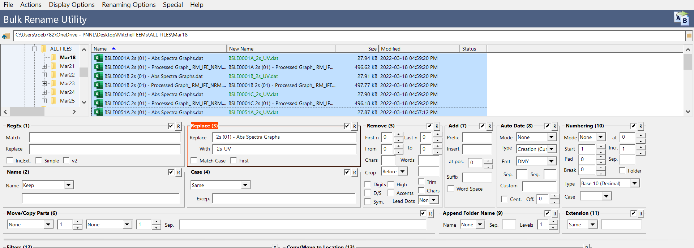

5) Open the file ‘SampleLog.xls’ and fill out columns for each sample



-A: Index: Simply the numeric order of entry (e.g. 1, 2, 3, 4, etc…)

-B: Analysis Date: Data samples were ran on instrument (not collected in the field)

-C: Sample Description: A brief description of the sample collected – 60-character max.

*Note: This description will be displayed on the top of final EEM figures

-D: Sample ID: Sample Identifier

*Note: This Sample ID will be used as the base naming for EEM figures

*\*Note: Biological replicates should be treated as a normal sample and have independent Sample IDs marked as A, B, C, etc…*

-E: Analytical Replicates: Numeric (1,2,3,etc…)

\**Analytical Replicates must have identical Sample IDs.*

-F: Integration Time: Integration time of sample (e.g. 1s, 2s, etc…)

-G: EEM File Name: Must include **EXACT** filename of EEM file. Don’t forget file extension (e.g. .dat, .xls, etc…)

-H: Absorbance File Name: Must include **EXACT** filename of Absorbance file. Don’t forget file extension (e.g. .dat, .xls, etc…)

-I: Absorbance Pathlength: For Aqualog, this will always be 1.

-J: Dilution Factor: Samples with absorbance at 254 nm greater than 0.3 must be diluted. Include dilution factor here as decimal format (e.g. a 2-fold dilution with 1 part sample and 1 part water will have a dilution factor of 0.5).

K: DOC concentration in mg/L of the original sample (not the diluted sample).

6) If you have access to Matlab, continue forward with instructions. If you do not have access to Matlab, generate a zip file and forward to someone who can do the processing for you.

**Section 2:** Matlab Setup (This step is only required for the first use of this code on any given computer. If you have already done this section, proceed to Section 3)

1) Download the latest version of the drEEM toolbox (<http://dreem.openfluor.org/>). Unzip the folder and place it somewhere accessible on you machine (e.g. the desktop).

2) Cut and paste the ‘Supporting Matlab Files’ folder over into your drEEM folder. It is fine for this folder to remain a subfolder of the main drEEM folder.

-This folder contains the following files:

A) DOCnorm B) manualplots C) SpectralIndicesExport D) EEM_Processing_Code

*\*Note: The SpectralIndicesExport file is valid for EEMs ran at MCRL after March 2022. For samples ran prior to this time, reach out to Alan Roebuck (*[*alan.roebuck@pnnl.gov*](mailto:alan.roebuck@pnnl.gov)*) for the correct version of this file. If you are processing EEMs on another Aqualog system, this file will need to be modified to ensure the correct wavelength outputs from your system are used in the calculations*

3) Open Matlab. Click on the ‘Set Path’ icon, then click the ‘Add with Subfolders…’ button. Select your drEEM folder. This will allow all of the subfolders and files within your drEEM folder to be accessed by Matlab

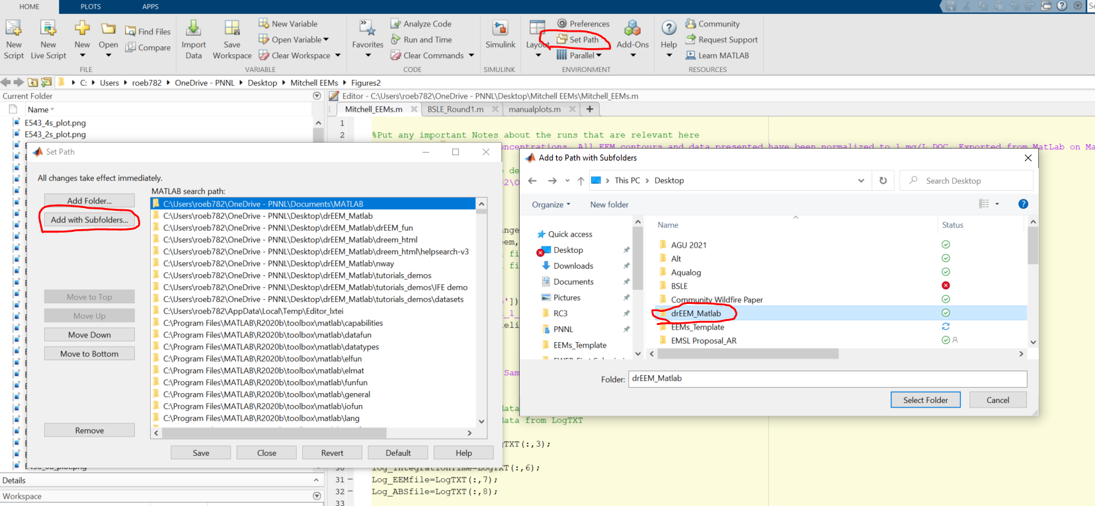

**Section 3:** Running Matlab script to export EEM data

1) Open in Matlab the file ‘EEM_Processing_Code’

Note: This code is good for samples ran in manual mode on the Aqualog. Samples ran using the Sample Queue may require edits to ensure Matlab reads the files correctly

2) Make edits to the Code in Section 1 as necessary. Note that any changes made will autosave

Line 4: Add any special notes about the samples or processing. These notes will be added to the ReadMe in the final data file.

*Note: Code corrects for dilutions and normalizes all data to

1 mg/L DOC. This information is generally specified here plus anything extra that might be important

Lines 7-13: Specify parameters for viewing or saving EEM figures

*Default settings are to autoscale (manualscale=false) the intensity scale of EEM contours, autosave EEMs (autosave=true), and save with a figure title (figuretitle=true)

*To set the intensity scale of all EEMs to be consistent, set the clim_max on line 10 to whatever value you choose and change line 11 to manualscale=true

*Note when autosave=true, nrows and ncols must each be set to 1. If you prefer not to save EEMs and simply want to view them, set autosave=false. You may then also change the nrows and ncols to view EEM contours in a matrix.

Line 17: Specify with true or false whether DOC concentrations are available in the sample log. When DOC is available, all data will be normalized to DOC concentration. When DOC is not available, EEMs will be exported based on Raw values. SUVA is also not available in the final sample file. It is **highly recommended** to only run the code when DOC is available to keep data outputs consistent. However, the code was made amenable here in the event one is in a bind and needs data quickly but may not have DOC.

Line 20: Specify the path to the folder that contains all of your data and the SampleLog

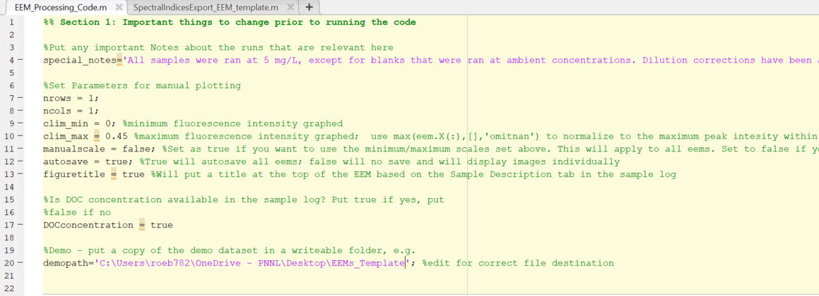

3) Press the run button:

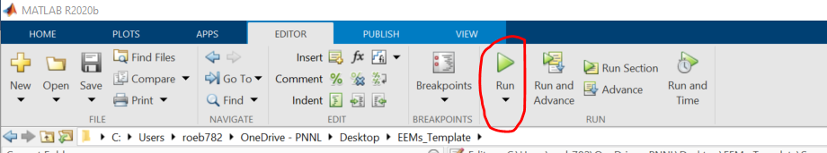

4) Matlab will now import the EEM and UV files, correct for dilutions, and if DOC is available, normalize data to 1 mg/L. All EEM contours will be saved in the ‘Figures’ folder. A file called ‘SpectralIndices.xlsx’ will be exported to the main folder.

5) Note, the code should run all the way through, if Matlab is telling you to ‘Have a beer’, all should be in the clear. If the code stops, there is likely an error. Most common errors are:

1) Actual file names are not identical to what is specified in the SampleLog

2) Extra files are included folders that aren’t specified in the SampleLog

3) If you made edits to SpectralIndicesExport file, Matlab may still tell you to have a beer, but an error can still occur if something is not correct in this file. If this occurs, this will lock the SpectralIndices.xlsx file and you will not be able to delete it or override it unless you restart the computer.